Exp - 7 Online Food Delivery System using Umbrello
Aim:
To design and model an Online Food Delivery System using Umbrello UML Modeller.
Procedure:
1. Open Umbrello UML Modeller.
2. Create a new UML project named Online Food Delivery System.
3. Create a Use Case Diagram with actors such as Customer, Restaurant, Delivery Agent, and Admin.
4. Add use cases such as Browse Menu, Place Order, Make Payment, Track Order, Manage Menu, and Update Delivery Status.
5. Create a Class Diagram showing classes like Customer, Restaurant, Menu, Order, Payment, and Delivery Agent with their attributes and methods.
6. Create an Activity Diagram representing the workflow from ordering food to delivery completion. 7. Validate the relationships, associations, and workflow.
8. Save the project and generate the UML diagrams.
Class Diagram:
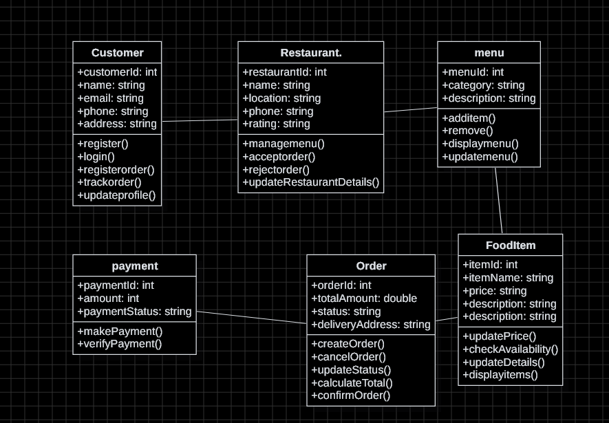

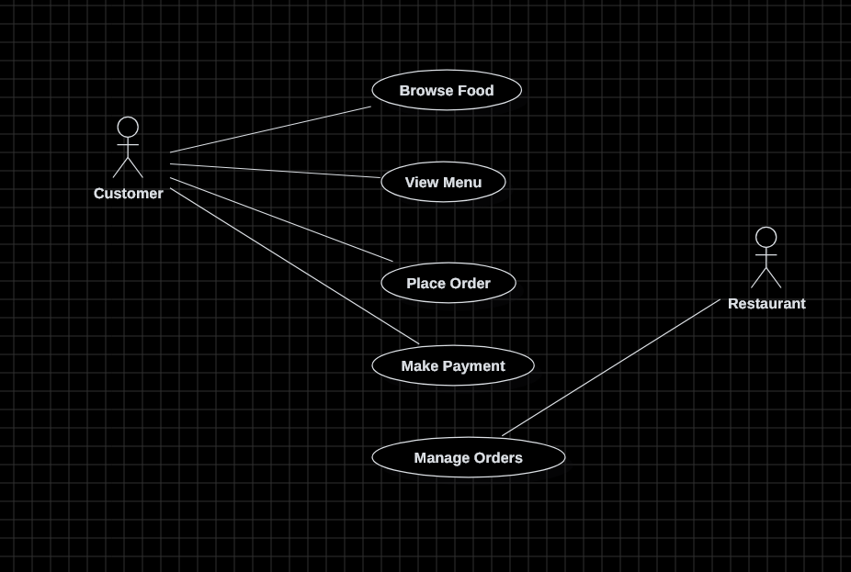
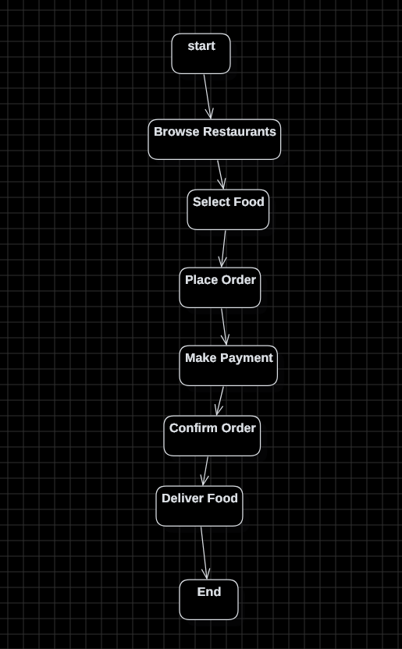

Result:
Thus, the Online Food Delivery System was successfully modeled using Umbrello UML Modeller, and the Use Case, Class, and Activity Diagrams accurately represented the system functionality and workflow.

